Yt : https://youtu.be/o_Oac27AS5w?si=MrGvDa0H6GFK-PmA

Practical 3 : Perform :
∙ Implement SPAN Technologies (Switch Port Analyzer)
∙ Implement SNMP and Syslog
∙ Implement Flexible NetFlow
Implement SPAN Technologies (Switch Port Analyzer)
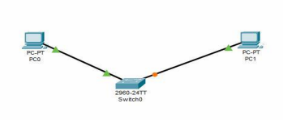
Address Table
Device | IP Address
PC0 | 10.0.0.2
PC1 | 10.0.0.3

Commands
monitor session 1 source int f0/0
monitor session 1 destination int f0/2
show monitor session 1
show monitor detail

Implement SNMP
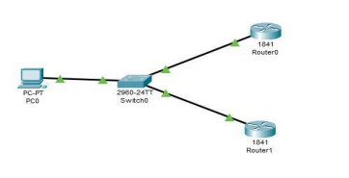
Device | Interface | IP Address
PC0 | PC0 | 172.168.1.2 /172.168.1.1
R1 | F0/0 | 172.168.1.1
R2 | F0/0 | 172.168.2.1

snmp-server community read ro
snmp-server community write rw
Goto MIB browser and do settings

Implement Syslog
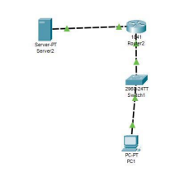
Device | Interface | IP Address
PC1 |  | 30.0.0.2/30.0.0.1
R2 | F0/0 server | 10.0.0.1
 | F0/1 PC1 | 30.0.0.1
server |  | 10.0.0.2/10.0.0.1

service timestamps log datetime msec
int f0/0.1
check syslog of server
Flow Simulator
int f0/0
ip flow ingress
ip flow egress
ip flow-export destination 10.0.0.2 99
ip flow-export source f0/0
show ip cache flow

